**NAT(NETWORK ADDRESS TRANSLATION)**

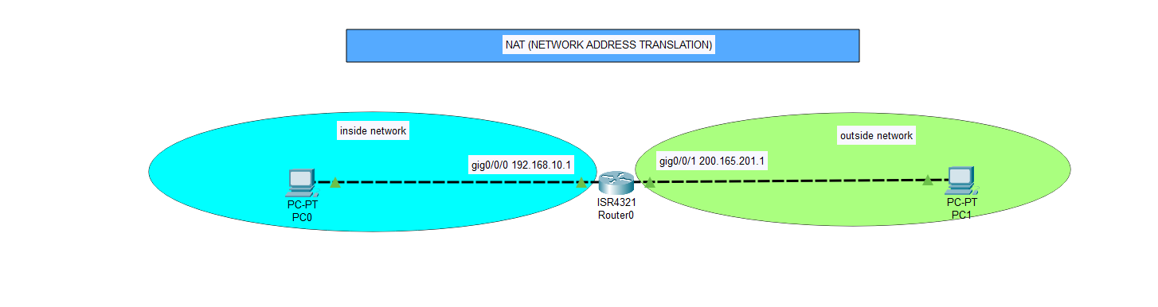

**Commands On router;**

Router>enable

Router#

Router#configure terminal

Router(config)#interface GigabitEthernet0/0/0

Router(config-if)#ip address 192.168.10.2 255.255.255.0

Router(config-if)#ip nat inside

Router(config-if)#no shut

Router(config-if)#ex

Router(config)#int gig 0/0/1

Router(config-if)#ip add 200.165.201.1 255.255.255.0

Router(config-if)#ip nat outside

Router(config-if)#no shut

Router(config-if)#ex

Router(config)#ip nat inside source static 192.168.10.1 200.165.201.1

Router(config)#do sh ip nat translation

Pro Inside global Inside local Outside local Outside global

--- 200.165.201.1 192.168.10.1 --- ---